**Secure Messaging System**

**Higher National Diploma in Software Engineering**

**Software Security Project Proposal**

**GAHDSE22.1F-022** **M.B.D. SEWWANDI**

**GAHDSE22.1F-018 R.L. Dinal Randika**

**National Institute of Business Management-Colombo 7**

**Introduction**

This proposal aims to develop and put into use a secure message encryption and decryption system that protects the integrity and confidentiality of communications sent between users. Input validation, username/password-based authentication and authorization, database storage with password hashing, and input encryption methods will all be used in this system to increase security.

# **Problem Definition**

# **Proposed Solution**

# **Objectives**

**UI Design**

**User Login Form**

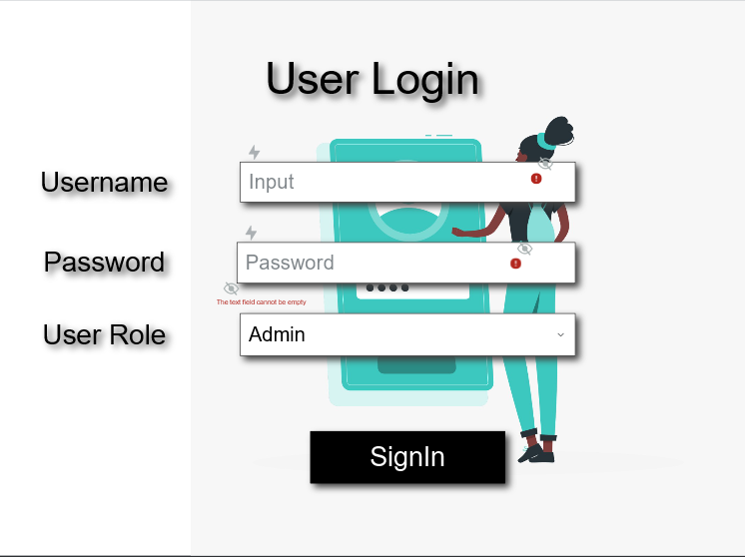

**Encryption Form**

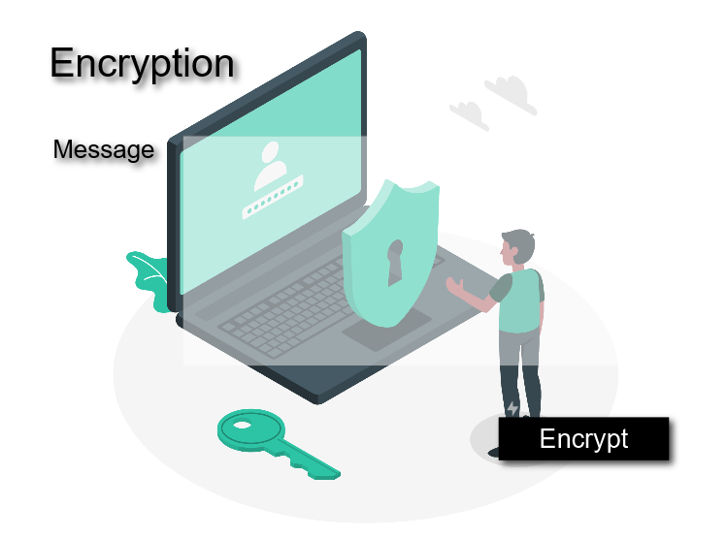

**Decryption Form**

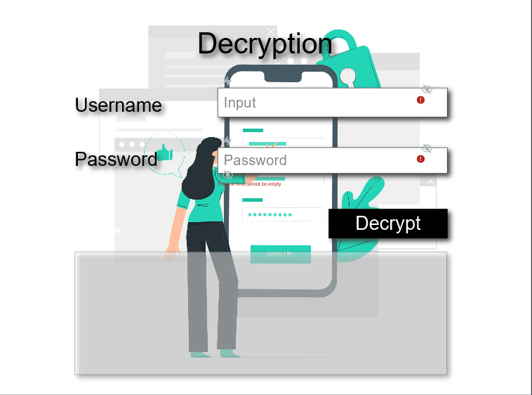

# **Flow Chart**

